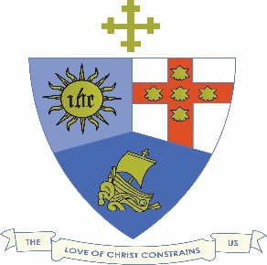
JAMAICA METHODIST DISTRICT
COVID 19 BULLETIN #3
March 12, 2020

Arising from the meeting between the Minister of Health and the Heads of Churches this morning, attended by the District Conference Secretary, Revd. Dr. Wayneford McFarlane, we are issuing this additional advisory;
- The presence of the virus in the island must be taken seriously because of its impact . people will die.
- Ministers of religion will be called upon to give comfort and relieve anxieties
- Churches and Chapels will remain open until further notice. Funerals and weddings will continue to be held until advised otherwise
- However the Environmental Forum planned by the District for Saturday March 14, 2020 has been postponed until further notice
- Churches are encouraged to develop a Disaster Plan chaired by a Planning committee. This Committee should look at different areas e.g.
  - Communication:
- Sensitize staff members. Have discussions about payment for staff if they have to stay home
- Communicate using email and text messages. Do not depend only on the pulpit to disseminate information
- Ensure that information passed on is credible. Monitor the situation locally as well as globally
- Listen to mainstream media
  - Cleaning
- Give cleaning protocols to church workers
- Ensure that cleaning includes switches and microphones. Steam may be used.
- Increase the number of times you clean the church
- Ensure that your toilets have soap and water
- Procure adequate cleaning supplies, sanitizers, chlorine bleach etc
- Gloves and masks in church are not necessary.

