Order of Worship
Musical Interlude

Centering song: Holy Spirit Rain Down
Holy Spirit, rain down, rain down
Oh, Comforter and Friend
How we need Your touch again
Holy Spirit, rain down, rain down
Let Your power fall
Let Your voice be heard
Come and change our hearts
As we stand on Your word
Holy Spirit, rain down

Call to Worship:
L: We gather today to worship a generous and loving God.
R Praise the Lord, O my soul!
L: We will praise the Lord as long as we have breath.
R Praise the Lord, O my soul!
L: We give thanks for all the gifts God has given us in His creation.
R: Praise the Lord, O my soul.
L: We give thanks for God’s help in times of need and His mercy in times of trouble.
R Praise the Lord, O my soul.

TIME OF ADORATION – Led by Choristers/ Praise Team
- Lord I Lift Your Name On High
- Give Me Jesus In The Morning
- Daniel’s God Surely Will Deliver
- Open the Eyes of My Heart, Lord

PRAYER OF ADORATION
L: O Lord, Giver of life and source of all good gifts. Today in a special way we adore your Holy Name as we recognize that all we have received comes from your gracious and loving hands.
R: We praise you and worship your Holy name.
L: You constantly call us to be stewards of your abundance, and to be caretakers of all you have entrusted to us. Help us to always use your gifts wisely and teach us to share them generously.
R: We praise you and worship your Holy name.
L: Send the Holy Spirit to work in, through, and around us, bringing your message to those we serve.
R: We praise you and worship your Holy name.
L: May we be faithful stewards as we bear witness to the love of Jesus Christ our Lord in our lives. This we pray with grateful hearts to you our generous God. Amen.

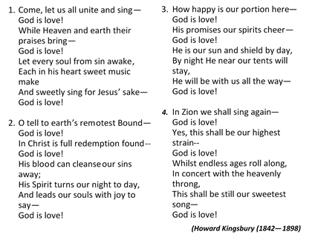
Hymn – “Come Let Us All Unite and Sing” [# 2 - VIP]

Time of Confession
Almighty God, as we come humbly and sincerely to you, we acknowledge that we have sinned against you and against each other in the thoughts we have encouraged, in the actions we have displayed and in the speech we have uttered. We declare that we are truly sorry for those times when we have displeased you. Help us O God, to think more of what we can give to life and think less of what we can get out of it. May we be mindful that we hold the gifts, talents, possessions and life itself as a trust from you to be used to bring honour and glory to your Holy Name as we serve our brothers and sisters. Save us and forgive us from only thinking of our own needs and desires; and help us to remember that it is more blessed to give than to receive, according to the teaching of our Lord and Saviour, Jesus Christ. Amen

Surrendering Song: “Create in Me a Clean Heart”
Create in me a clean heart, oh God
And renew a right spirit within me.
Create in me a clean heart, oh God
And renew a right spirit within me.
Cast me not away from Thy presence, oh Lord
And take not Thy holy spirit from me
Restore unto me the joy of Thy salvation
And renew a right spirit within me
Keith Green (1953—1982)

Assurance of Forgiveness
L: All generous God, you poured yourself out in creation, were totally spent in Christ’s death on the Cross, and continue to give yourself through the gift of Your Holy Spirit to us.
ALL: Thank you for forgiving us and cleansing us, and as we continue to be your stewards, grant us the grace to feel your presence, the wisdom to heed your word, and the courage to stay the course in Jesus’ name we pray. Amen.

FATHER’S DAY SPECIALS: -
- Puppetry Ministry - Bro. Victor McSweeney
- Father’s Day Reflections - Pastor Clifton Brown

MINISTRY OF THE WORD
Collect: - Bro. Courtney Moseley
Lord, you have taught us that all our doings without love are nothing worth: send your Holy Spirit and pour into our hearts that most excellent gift of love, the true bond of peace and of all virtues, without which whoever lives is counted dead before you. Grant this for your only Son Jesus Christ's sake. Amen

Old Testament: - Deuteronomy 6: 1—9 -Bro. Clava Mantock Jnr.

Responsive Reading: Psalm 128 -Led by-Sis. Nadia Wright
L ¹Blessed is everyone who fears the Lord,
Who walks in His ways.
R ² When you eat the ^{[a]}labor of your hands,
You shall be happy, and it shall be well with you.
L ³ Your wife shall be like a fruitful vine
In the very heart of your house,
Your children like olive plants
All around your table.
R ⁴ Behold, thus shall the man be blessed
Who fears the Lord.
L ⁵ The Lord bless you out of Zion,
And may you see the good of Jerusalem
All the days of your life.
ALL ⁶ Yes, may you see your children’s children.
Peace be upon Israel!

Epistle: Hebrews 12: 1 – 11 – Read byBro. Sharyf Manning
Ministry Item: - Red Hills Methodist Men’s Group
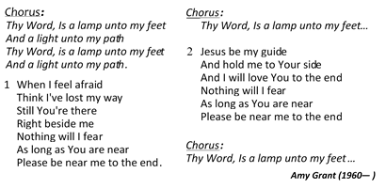
Song of Preparation: “Thy Word, Is a Lamp Unto My Feet”

Gospel - Mark12:41—44 – Read by Bro. Camara Nelson

Sermon – Rev’d Stephen Mullings
(Superintendent Minister, Lyndhurst)
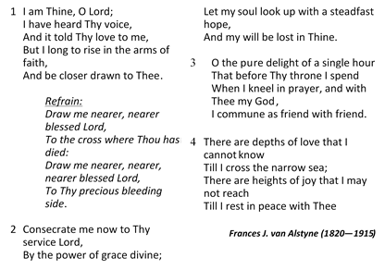
Hymn of Commitment– “I Am Thine O Lord” [# 223VIP]

ANNOUNCEMENTS - Bro. Courtney Moseley

TITHES &Offertory
Time of Intercession: -Led byBro. Courtney Moseley
God of hope, there are many among us and in our communities who are hurting. There are those in our midst and in our communities who are suffering from physical ailments. There are those who are suffering from the loss of loved ones. There are those who suffer from mental, spiritual and emotional distress. There are those who are having marital issues or family problems or those suffering from loneliness. There are those who are suffering from financial difficulties or joblessness. There are those who are suffering from other difficulties and we come to you our loving, caring and compassionate God asking you to have mercy and guide all those in need.
So often the world around us seem to offer little hope. The world often offers us more pain and turmoil but you offer us renewed hope in a bright tomorrow. You O God, offer us a multitude of resources in order to share your hope with others. Help us to look out for others as we give food to the hungry, drink to the thirsty, welcome the stranger, clothes to the naked, and care to the sick and imprisoned so that through the gifts you have provided we may bring your joy to the world. Amen.

The Lord’s Prayer
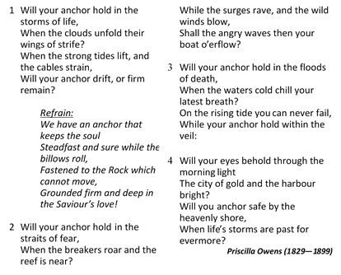
Closing Hymn- “Will Your Anchor Hold …” [# 344VIP]

Benediction
The Lord bless you, and keep you, make His face shine upon you and begracious to you. The Lord turn His face towards you, and give you peace.Amen.

The Methodist Church in the
Caribbeanand the Americas (MCCA)

Jamaica District

METHODIST VOICES IN WORD AND SONG
TELEVISION MINISTRY
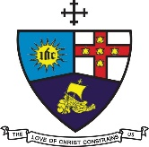

3rdLord’s Day After Pentecost

Father’s Day

Sunday, June 21, 2020

DIVINE WORSHIP

Preacher: Rev’d Stephen Mullings
Worship Leader: Bro. Courtney Moseley

Organist: Bro. Donovan Rookwood
Choristers: Sis. Kahlila Bonner
Sis. Anoula Barnes
Sis. Nadia Beech
Bro. Noel Henry
Bro. Phillip Matthews
Bro. Mark Auguste
Bro. Enroy Prawl
Bro. Wayne Stewart

(Choristers and Readers fromthe Red Hills Congregation)

District President: Bishop Christine Gooden-Benguche
District Secretary: Rev’d Dr. Wayneford McFarlane
A blessed welcome to all worshippers on
this wonderful Father’s Day!

