Order of Worship
Organ Prelude:

Choral Introit: “Let All the World in every Corner sing” [# 10VIP]

Call to Worship:
L: The body is made up of many parts. Today we gather from different backgrounds: different people with different talents and gifts, to worship God and give thanks for each other.
R: O let your Spirit fall afresh on us.

Opening Hymn: #392 VIP “And are we yet alive…”(Verses 1,2 & 6)
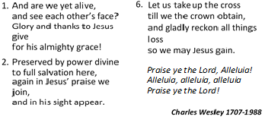

Prayers of Adoration:
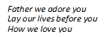
L: God you are our powerful Creator, our dying Saviour and our comforting spirit, You are also our loving Father.
ALL: Chorus: (sung by all)

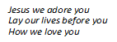
L: Lord, you came to us in Jesus Christ, died for us but was raised from the dead to save us
ALL: Chorus: (sung by all)

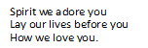
L: We know you Lord as being a dynamic, refreshing and uplifting Spirit. You are the Holy Spirit, our teacher, counselor, comforter, protector and friend.
ALL: Chorus: (sung by all)

ALL: God the Father, the Son and the Holy Spirit with all our heart, might, soul and strength, we praise you. Amen

Act of Confession:
Let us now examine ourselves before God, humbly confessing our sins and watching our hearts lest by self-deceit we shut ourselves out from his presence.
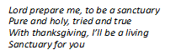
Prayer Chorus:

Prayers of Confession:
L: Let us confess our negligence in caring for our planet Lord, it seems we do not understand how our daily thoughtlessness and laziness impacts on the whole of creation
ALL: Lord we ask you to forgive us
L: Lord God, Creator of the World and God of all humanity, we ask forgiveness for the harm and destruction we have done to your creation
ALL: Lord, we ask you to forgive us
L: Sometimes we lose our way. We listen to the myriad voices that claim to speak your word and truth. We tend to confuse our ways with your ways, causing our sisters and brothers to stumble.
ALL: Have mercy upon us and forgive us, O Lord.
L: Give us hands to reach out in service, not to reach out and grasp what we can get. Give us a heart to discern your truth and your voice
ALL: Have mercy and forgive us, O Lord

Prayer of Thanksgiving:
Creator God, we thank you for the earth you have given to us! With joy we praise you for the high mountains and their trees, for the rushing waters of Caribbean rivers which give the breath of inspiration and the joy of fruitfulness, for the forests so luxuriant in foliage, the glorious tall trees and the abundance of good weather .Still more, we praise you for the wisdom for living, and the commitment which our courageous ancestors taught us. Open our eyes to behold your gracious hand in all your works; that we may learn to serve you with gladness, faithfully managing your bounty; for the sake of him by whom all things were made, your Son, Jesus Christ our Lord. Amen.

ACT OF THANKSGIVING:
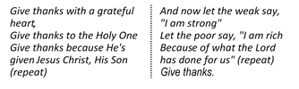
Chorus: “Give Thanks witha Grateful Heart”

Time of Praise–

Children & Youth Focus: - Bro. Victor McSweeney

Message from the President - MCCA WOMEN Read by Mrs. Patricia
Newell Pennant, Secretary, MCCA Women

Hymn—MCCA Women Acceptance Hymn (All women stand)
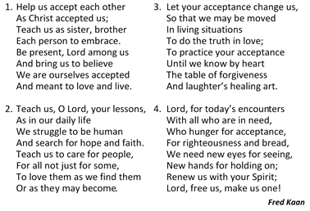

MINISTRY OF THE WORD
The Collect for MCCA Women Lord’s Day:
Almighty God who created male and female in your image for governance in your world, and ministry in your name, grant that under your direction and enablement we will do all that is pleasing in your sight. We pray in the name of Jesus Christ our Saviour and Lord. Amen.

Old Testament. Lesson: Joel 2: 28-32 - – Mrs. Andrea Graham
(MCCA Women District Rep.)

Responsive Reading: Magnificat – Luke 1:46-55– Dr. Angella Mullings
L: ⁴⁶ And Mary^{[a]} said,
“My soul magnifies the Lord,
R: ⁴⁷ and my spirit rejoices in God my Savior,
L: ⁴⁸ for he has looked with favor on the lowliness of his servant.
Surely, from now on all generations will call me blessed;
R: ⁴⁹ for the Mighty One has done great things for me, and holy is his name.

L: ⁵⁰ His mercy is for those who fear him
from generation to generation.
R: ⁵¹ He has shown strength with his arm he has scattered the proud in the thoughts of their hearts.
L: ⁵² He has brought down the powerful from their thrones,
and lifted up the lowly;
R: ⁵³ he has filled the hungry with good things,
and sent the rich away empty.
L: ⁵⁴ He has helped his servant Israel,
in remembrance of his mercy,
ALL: ⁵⁵ according to the promise he made to our ancestors,
to Abraham and to his descendants forever.”
Gloria Patri…

Poem: ‘Arise, Woman of God’ – Mrs. Camielle Michael-Patterson
Gospel: Mark 16:9-16 – Mrs. Andrea Crossfield
Sermon: - Dr. the Rev’d Karen Durrant McSweeney
Announcements
Prayer of Intercession
L: We remember in prayer all the peoples of the world who seek liberty, equality, and human dignity. We lift up the needs of the hungry, the homeless, and the disadvantaged. Lord hear our prayer.
R: And let our cry come unto you
L: Lord, in this time of COVID19, we pray for all the front-line workers, first responders and persons affected by the Coronavirus. Keep them, good Lord, under the shadow of your mercy in this time of uncertainty and distress. Sustain and support the anxious and fearful, lift up all who are brought low; that we may rejoice in your comfort knowing that nothing can separate us from your love in Christ Jesus our Lord. Lord, hear our prayer
R: And let our cry come unto you
L: We pray for those who are guiding our nation at this time and shaping national policies. Continue to give them wisdom to made decisions that meets with your will. That they may maintain values which we hold dear. Lord, hear our prayer
R: And let our cry come unto you
L: We pray for the church universal, which encompasses different lands, cultures, and languages, but exist under one lordship in Jesus Christ. We pray for the World Methodist Council, MCCA Connexional Officers, our District Bishops, our District Officers and Congregations. Lord, hear our prayer
R: And let our cry come unto you
L: We pray for our children and young people. May they find you in all they do using your childhood example to live from day to day. Lord, hear our prayer.
R: And let our cry come unto you
L: We ask a special blessing on MCCA Women. We give thanks for them as they continue to work diligently throughout the Connexion. Help them to continue to be committed members working for the betterment of their church and their community. Lord hear our prayer.
R: And let our cry come unto you. Amen

The Lord’s Prayer (To be sung - Caribbean Version) [# 26 VIP]
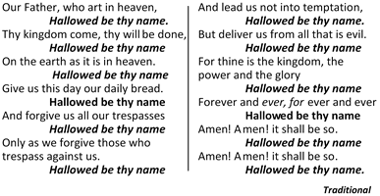

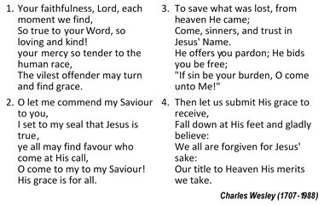
Closing Hymn: “Your Faithfulness Lord…” [ #179VIP]

Benediction
May the grace of our Lord Jesus Christ, and the love of God and the fellowship of the Holy Spirit be with us all, now and evermore. Amen.

The Methodist Church in the
Caribbean and the Americas (MCCA)

Jamaica District

METHODIST VOICES IN WORD AND SONG
TELEVISION MINISTRY
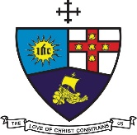

MCCA WOMEN LORD’S DAY

Sunday, June 28, 2020

DIVINE WORSHIP

MCCA Women Motto: In Service for Christ
Theme: Women Persevering Through Adversity

Preacher: Dr. the Rev’d Karen Durrant McSweeney
Liturgist: Sis. Olyvya O’Connor, Minister-in-Training

Organist: Bro. Audley Davidson
Choristers: Sis. Lilieth Deacon
Sis. Shirley Carby
Sis. Valerie Hinds
Sis. Marie Miller
Sis. Sonia Cole
Sis. Patricia Newell Pennant
Praise Team: Sis. Cassie-Ann King
Sis. Kerry-Ann Saddler

District President: Bishop the Rev’d Christine Gooden- Benguche
District Secretary: Rev’d Dr. Wayneford McFarlane

A warm welcome to all worshippers on this
glorious MCCA Women’s Lord’s Day!

