Order of Worship
Introit Hymn # 152 [VIP] - “Holy Spirit Hear Us” (Saxthorpe Choristers)
Call to Worship: - Rev’d Claudette Campbell

L Holy! Holy! Holy! Lord God Almighty, who was and who is, and who is to come.
ALL Holy! Holy! Holy! Is the Lord of hosts, the whole earth is full of His glory.

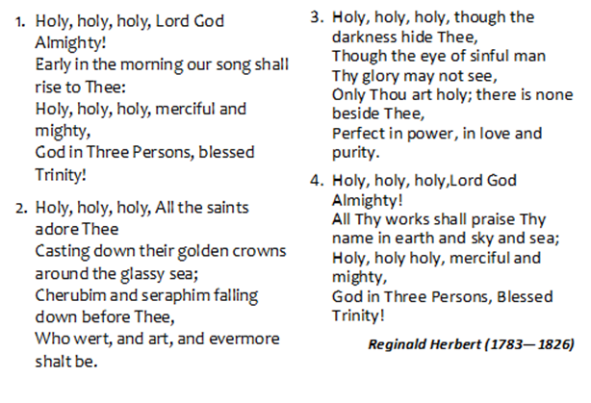
Hymn # 8 [VIP] – “Holy, Holy, Holy, Lord God Almighty”

Prayer of Adoration - Rev’d Claudette Campbell

Prayer of Confession: - Rev’d Claudette Campbell
L Let us confess our sins to God and pray for forgiveness.
Merciful God, we have not loved you with all our heart, mind, soul and strength, and our worship and witness fall short of our calling as disciples.
R Have mercy upon us and forgive us, O Lord.
L Merciful God, we have not loved our neighbours as you have taught us, and our relationships have been marred by the sin of selfishness, pride and thoughtlessness.
R Have mercy upon us and forgive us, O Lord.
L Merciful God, you have provided the way of eternal life for us in Jesus Christ, yet we seek that life elsewhere. You have given us power through your Holy Spirit to have victory over all evil, yet we often fail, and are defeated in our fight against lukewarmness, sin and death.
R Have mercy upon us and forgive us, O Lord.
[The congregation shall confess in silence]
L Let us confess together:
ALL Be merciful to me, O God, because of your constant love,
Because of your great mercy, Wipe away all my sins, Wash away all my evil, and make me clean from sin!
I acknowledge my faults, and am always conscious of my sins. Create a pure heart within me, O God, and put a new and loyal spirit in me. Give me again the joy that comes from your salvation, and make me willing to obey you, for the sake of Jesus Christ my Lord. Amen.
Praise in Worship - Sis. Winsome Exell (Saxthorpe)
Sis. Judy-Marie Campbell (Saxthorpe)
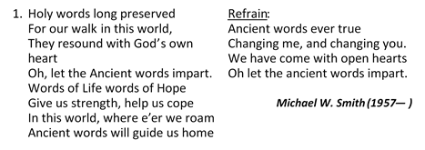
HYMN # 160 [VIP] - “Ancient Words” (verse 1 and Chorus)

MINISTRY OF THE WORD
Collect: - Rev’d Claudette Campbell
Almighty God you have given us your servants grace, by the confession of a true faith, to acknowledge the glory of the eternal Trinity and in the power of the divine majesty to worship the Unity: keep us steadfast in this faith, that we may evermore be defended from all adversities; through Jesus Christ our Lord, who is alive and reigns with you, in the unity of the Holy Spirit, one God, now and forever. Amen

Old Testament: - Genesis 1:1-2:4a – Read by M.I.T. Joelle Alfred

Responsive reading: Psalm: 8:1—9 (VIP 586)
Led by- Rev’d Claudette Campbell
L ¹ O Lord, our Sovereign,
how majestic is your name in all the earth!
You have set your glory above the heavens.
R ² Out of the mouths of babes and infants
you have founded a bulwark because of your foes,
to silence the enemy and the avenger.
L ³ When I look at your heavens, the work of your fingers, the moon and the stars that you have established;
R ⁴ what are human beings that you are mindful of them,
mortals^{[a]} that you care for them?
L ⁵ Yet you have made them a little lower than God,^{[b]}
and crowned them with glory and honor.
R ⁶ You have given them dominion over the works of your hands; you have put all things under their feet,
L ⁷ all sheep and oxen,
and also the beasts of the field,
R ⁸ the birds of the air, and the fish of the sea,
whatever passes along the paths of the seas.
ALL ⁹ O Lord, our Sovereign,
how majestic is your name in all the earth!

New Testament: – 2 Corinthians 13:11–13 – M.I.T Joelle Alfred
Gospel - Matthew 28:16–20 – Bishop C. Gooden Benguche
Sermon – Bishop Christine Gooden Benguche
Nicene’ Creed [PAGE 72 MPB] - Led by Rev’d Claudette Campbell

We Believe In One God, the Father Almighty, Creator of heaven and earth, and of all that is, seen and unseen.
We believe in one Lord Jesus Christ, the only Son of God, eternally begotten of the Father, God from God, Light from Light, True God from True God, Begotten, not made, of one Being with the Father. Through Him all things were made. For us human beings, and for our salvation, he came down from heaven. By the power of the Holy Spirit he became incarnate from the virgin Mary and became a human being. For our sake he was crucified under Pontius Pilate; He suffered death and was buried. On the third day He rose again in accordance with the Scriptures. He ascended into heaven and is seated at the right hand of the Father. He will come again in glory to judge the living and the dead and his Kingdom will have no end.
We believe in the Holy Spirit, the Lord, the Giver of Life who proceeds from the Father and who, with the Father and the Son, is worshipped and glorified. He has spoken through the prophets.
We believe in the one holy, catholic and apostolic Church. We acknowledge one baptism for the forgiveness of sins. We look for the resurrection of the dead, And the life of the world to come. Amen.

Hymn # 307 [VIP] – “Father, Son and Holy Ghost …”
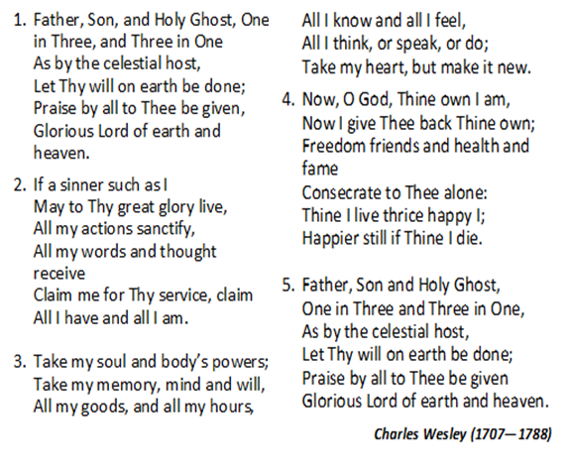

Special Announcement - Rev’d Dr. Wayneford McFarlane
Offertory
Prayers of Intercession: (The Church’s Message) (see insert)
L Lord, in Your mercy:

R Hear our prayer!

The Lord’s Prayer

The Sacrament of The Lord’s Supper
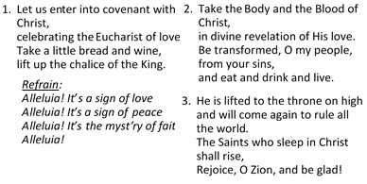
Communion Hymn # 429 {VIP] – “A Sign of Love …”

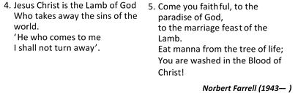

Communion Liturgy (PG 76 MPB)
Closing Hymn # 407 [VIP] – “The Church’s One Foundation …”
Yet saints their watch are keeping,
Their cry goes up: how long?
And soon the night of weeping
Shall be the morn of song.
- ‘Mid toil and tribulation,
And tumult of her war,
She waits the consummation
of peace for evermore,
Till with the vision glorious
Her longing eyes are blest,
And the great Church victorious
Shall be the Church at rest.
- Yet she on earth has union
With God the Three in One,
And mystic sweet communion
With those whose rest is won,
O happy one and holy!
Lord, give us grace that we,
Like them, the meek and lowly,
On high may dwell in Thee.
Samuel J. Stone (1839—1900)

- The Church’s one Foundation
Is Jesus Christ her Lord;
She is His ne creation
By water and the word;
From heaven He came and sought her
To be his Holy bride,
With His own blood He bought her
And for her life He died.
- Elect from every nation,
Yet one o’er all the earth,
Her charter of salvation
One Lord, one faith, one birth;
One holy name she blesses,
Partakes one holy food,
And to one hop she praises
With every grace endued.
- Though with a scornful wonder
Men see her sore oppressed
By schisms rent asunder,
By heresies distressed,

Benediction
From God the Father who first loved us, and made us accepted in the Beloved: To God the Son, who loved us, and washed us from our sins:
To God the Holy Ghost, who sheds the love of God abroad in our hearts, Be all love and all glory For time and for eternity. Amen

Service will be carried on:
- Mercy and Truth Ministries: 1:30 – 2:30 pm
  - www. mercyandtruth.tv
CABLE Channel 601 FLOW
Channel 19 DIGICEL

The Methodist Church in the Caribbean and the Americas
Jamaica District

METHODIST VOICES IN WORD AND SONG
TELEVISION MINISTRY
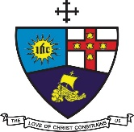

Festival of the Holy Trinity

Sunday, June 7, 2020

SERVICE OF WORD
AND SACRAMENT

Officiating Clergy:
Preacher: Rev’d Christine Gooden- Benguche
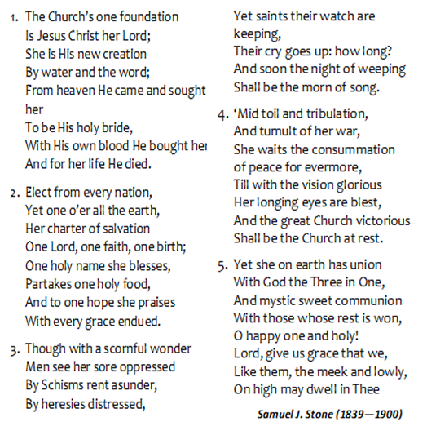
Liturgist: Rev’d Claudette Campbell
Rev’d Dr. Wayneford McFarlane
M.I.T. Joelle Alfred

Organist: Sis. Melrose Davies
Accompanist: Bro. Andre Taylor
Choristers: Sis. Yvonne Brown
Sis. Valerie Hinds
Sis. Marie Miller
Sis. Yvonne Patterson
Bro. Oliver Campbell
Bro. Nigel Haye
Praise Team: Sis. Winsome Exell
Sis. Judy-Marie Campbell

District Bishop: Rev’d Christine Gooden- Benguche
District Secretary: Rev’d Dr. Wayneford McFarlane
A warm welcome to all worshippers!

