Order of Worship

Musical Interlude

Centering song: Welcome into this place
Welcome into this place
Welcome into this broken vessel
You desire to abide
In the praises of your people
So we lift our hands
And we lift our hearts
As we offer up this praise unto Your name

Call to Worship:
L: We are called to proclaim the undiluted Gospel of Jesus Christ!
R: We tell with joy the message of Salvation for all through Christ!
L: We are called to proclaim the message of hope that Jesus brings!
R: We happily declare that there is hope in God, who is worthy to be praised!

TIME OF ADORATION – Led by the Praise Team
- Come, let’s magnify the Lord
- Blessed by the name of the Lord
- Jehovah is Your Name
- You deserve the glory
- Here I am to worship
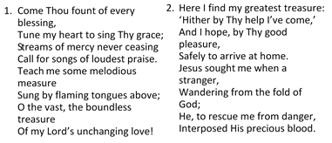
Hymn ‘‘Come Thou Fount of Every Blessing” [# 236 [VIP]

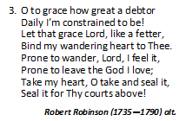

TIME OF CONFESSION

L: Let us quiet our hearts before God, reflecting on the sinful state of our being, and seek His forgiveness.

(A period of silence is observed for personal confession)

L: Saving Yahweh, we confess that we have drifted from Your presence, failing to welcome You even when You come to us in this time of isolation, so we may hear from You and grow in You. We confess that, like we have responded in this time of physical/social distancing, that we have continued to practise spiritual distancing from You and those whom You called us to rescue. We confess that, like governments have imposed lockdowns in our communities, we too have implicitly imposed a ‘lockdown’ on regular communion with Your and the spreading of the gospel of Jesus Christ, as we have allowed ourselves to become non-functional outside of the four walls of the church buildings.
R: Purifying God, purge us even now; blot out our transgression and make us whole. Amen.
Surrendering in Song
I surrender all to You, Everything I give to You
Withholding nothing, Withholding nothing.

I give myself away, I give myself away,
So You can use me.
Here I am, Here I stand,
Lord, my life is in Your hands
Lord I’m longing to see,
Your desire revealed in me.
I give myself away. . ..

Assurance of Forgiveness:
L: We confess with our mouths. We believe in our hearts. We are forgiven and saved by God’s amazing grace!
ALL: Amen. Thanks be to God!

PUPPETRY MINISTRY: - Bro. Victor McSweeney (Coke Congregation)

MINISTRY OF THE WORD
Collect: - Pastor Sean A. Davis
O God, the strength of all those who put their trust in you, mercifully accept our prayers and, because through the weakness of our mortal nature we can do no good thing without you, grant us the help of your grace, that in the keeping of your commandments we may please you both in will and deed; through Jesus Christ your Son our Lord. Amen.
Old Testament: Genesis 18:1-15 Bro. Jerome Arnold
(Gordon Town Congregation)

Responsorial Reading: Psalm 116:1-2,12-19 [VIP #634]
Led by: Dr. Jodie-Ann Hylton (Saxthorpe Congregation)

L: ¹ I love the Lord, because he has heard, my voice and my supplications.
R: ² Because he inclined his ear to me, therefore I will call on him as long as I live.
L: ¹² What shall I return to the Lord for all his bounty to me?
R: ¹³ I will lift up the cup of salvation and call on the name of the Lord,
L: ¹⁴ I will pay my vows to the Lord in the presence of all his people.
R: ¹⁵ Precious in the sight of the Lord is the death of his faithful ones.
L: ¹⁶ O Lord, I am your servant; I am your servant, the child of your serving girl. You have loosed my bonds.
R: ¹⁷ I will offer to you a thanksgiving sacrifice and call on the name of the Lord.
L: ¹⁸ I will pay my vows to the Lord in the presence of all his people,
R: ¹⁹ in the courts of the house of the Lord, in your midst, O Jerusalem. Praise the Lord!
Gloria Patri…

Epistle: Romans 5:1-8 - Bro. Dane Morrison (Wesley Congregation)

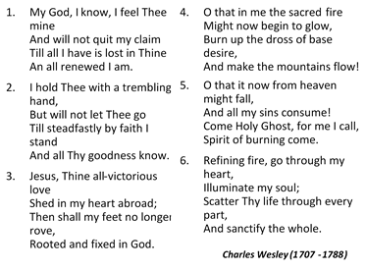
Hymn of Preparation: “My God! I know, I Feel Thee Mine” [# 228 VIP]

Gospel: MATTHEW 9:35-10:23 Sis. Jodi-Kaye Martin
(Pembroke Hall Congregation)

SERMON: - Sis. Joelle Alfred, Minister-in-Training

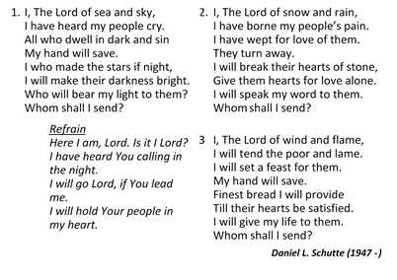
Hymn of Commitment: “Here I Am Lord” [# 455 VIP]

ANNOUNCMENTS, TITHES & OFFERETORY - Pastor Sean A. Davis

TIME OF INTERCESSION: - Led by Pastor Sean A. Davis
L Eternal God, we come to you on behalf of those with longing desires for new experiences, void of sorrow, aches, pains and hardship.
R Lord, create something new among Your people today.
L Lord, we remember those who have found themselves in barrenness of various sorts, and have perhaps lost hope of producing desired fruits. Grant Lord, that they may become pregnant with purpose like Sarah and give birth to hope, joy and peace.
R Lord, turn our longing into fulfilment.
L God, who turns graves into gardens, we pray for those situations that lay dead in our lives – the lost jobs, friendships, relationships and source of happiness.
R Lord, may You breathe life into these circumstances, and cause us to dwell in green pastures.
L We place in Your hands, those who in this time of isolation are feeling alone, abandoned and without support. Remind us, that you are with us all the day long.
R Remind us, You will never leave nor forsake us.
L Omnipresent God, we pray for those who have disconnected from You, and have found themselves on spiritual ventilators, battling for survival in this season.
R Restore and reconnect us with Your Spirit, O God.
L As the world seeks after a vaccine for COVID-19, may Your people be even more diligent in receiving the vaccine that is in the blood that was shed on Calvary to heal humanity from sin.
R May the blood that never loses its power redeem Your people in this season.
L Lord, we remember those whose cries are for justice and liberty; those, who cry for the world to recognize that all lives matter. May we all go into introspection and call on ourselves, in like manner, to suppress all tendencies to oppress others on the grounds of class, race, creed, resources or the lack thereof and state of spiritual ‘heights’.
R God of all human creation, fill the peoples of this world with hearts of love, that we will see each other as equals and share in hoping for the promise of brighter tomorrows. Amen.

THE LORD’S PRAYER

Closing Hymn: “Standing On the Promises” [# 207a VIP]
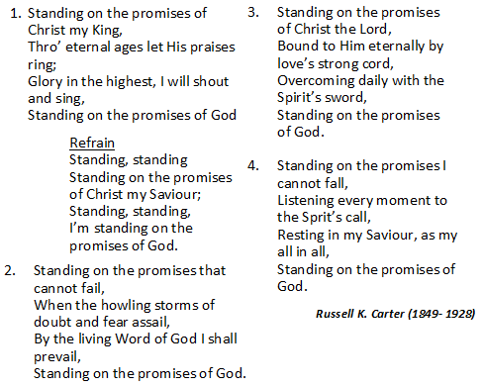

Benediction – Sis. Joelle Alfred
The Lord bless you, and keep you, make His face shine upon you and be
gracious to you. The Lord turn His face towards you, and give you peace.
Amen.

The Methodist Church in the Caribbean
and the Americas (MCCA)

Jamaica District

METHODIST VOICES IN WORD AND SONG
TELEVISION MINISTRY
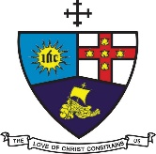

2nd Lord’s Day After Pentecost

Sunday, June 14, 2020

DIVINE WORSHIP

Preacher: Sis. Joelle Alfred, Minister-in-Training
Worship Leader: Pastor Sean A. Davis

Organist: Bro. Donovan Rookwood
Choristers: Sis. Cassie-Ann King
Sis. Jodie-Ann Hylton
Sis. Jodi-Kaye Martin
Bro. Dane Morrison
Bro. Jerome Arnold

Puppeteer: Bro. Victor McSweeney

District President: Bishop Christine Gooden-Benguche
District Secretary: Rev’d Dr. Wayneford McFarlane

A blessed welcome to all worshippers on
this beautiful Youth Sunday!

