Order of Worship
Introit Hymn: “Turn Your Eyes Upon Jesus”
‘Turn your eyes upon Jesus
Look full in His wonderful face
And the things of earth
will grow strangely dim
In the light of His glory and grace’
Call to Worship: -
L O give thanks to the Lord, call on his name, make known his deeds among the peoples.
R Sing to him, sing praises to him; tell of all his wonderful works.
L Glory in his holy name; let the hearts of those who seek the Lord rejoice.
R Seek the Lord and his strength; seek his presence continually.
ALL: Remember the wonderful works he has done, his miracles, and the judgments he has uttered, O offspring of his servant Abraham, children of Jacob, his chosen ones.
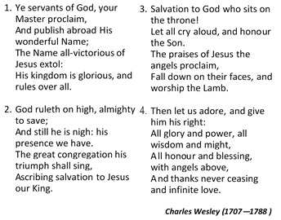
Opening Hymn “Ye Servants of God. . .”” [# 248 VIP]

Prayer of Adoration - Sis. Dr. Sherlette Rookwood-Brown
Our God and Heavenly Father, we come before you at this time to praise you and adore you. How awesome is your power, that You can allow the waters to
rise and the mountains to crumble; yet powerful Lord, you keep the most helpless among us safe and alive because it is not part of Your design for them to perish and die. How great is your wisdom, that You can lead us and guide us,
close a door and open another, give us trials as well as blessings, and shepherd us all our lives until we are safe and finally home. How deep is your love and how boundless your mercy, that no matter how grave our problems, how terrible our mistakes, how shameful our secrets, and how often we stumble and fall, we can pray to You for forgiveness, we can find in You our salvation. You are awesome!
Chorus: You are awesome in this place mighty God
You are awesome in this place, Abba Father
You are worthy of our praise,
to you our hearts we raise
You are awesome in this place, mighty God

Prayer of Confession
Forgiving God, we confess that it is often difficult for us to be your people. You have called us to be the church and to continue the mission of Jesus Christ to our lonely and confused world. Yet in truth, we admit that we are more prone to apathy than action; isolation than involvement; callousness than compassion; obstinance than obedience; legalism than love; rigidness than receptiveness; pessimism than praise; we are more prone to be self-filled than Spirit-filled. Gracious Lord, freely pour out your mercy on us and forgive our sins. Remove those obstacles that hinder us from being your representatives in a broken world. Awaken our hearts to the promised gift of your indwelling Spirit … (even as we make our personal confessions in silence) … Hear our prayers in Jesus’ powerful name. Amen.
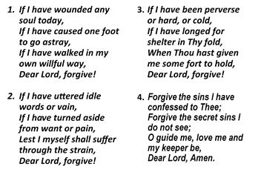
(We continue our prayer of confession as we sing:)

Words of Assurance
L Romans 4: 7 declares ‘Blessed are those whose transgressions are forgiven; whose sins are covered. Blessed is the one whose sin the Lord will never count against him.’ Sisters and brothers, we are forgiven in Jesus Christ.
P Amen. Thanks be to God.

Prayer of Thanksgiving - Sis. Dr. Sherlette Rookwood-Brown
Almighty God, Father of all mercies, we your unworthy servants give you humble thanks for all your goodness and loving-kindness to us and to all whom you have made. We thank you for our creation, preservation, and all the blessings of this life; but above all for your immeasurable love in the redemption of the world by our Lord Jesus Christ; for the means of grace, and for the hope of glory. And, we pray, give us such an awareness of your mercies, that with truly thankful hearts we may show forth your praise, not only with our lips, but in our lives, by giving up ourselves to your service, and by walking before you in holiness and righteousness all our days; through Jesus Christ our Lord, to whom, with you and the Holy Spirit, be honour and glory throughout all ages. Amen.

Chorus: God is so good; God is so good,
God is so good; God’s so good to me.

Welcome
Special Selection: – Sis Justine Rookwood
MINISTRY OF THE WORD
Collect: - Sis. Dr. Sherlette Rookwood-Brown
Almighty God, we are grateful that you communicate your wisdom and truth to us. Prepare us now to receive with eagerness your living and active Word. Blow your Holy Spirit through these pages that they might penetrate deeply into our lives, directing us how to live. Enable us to participate in this marvel of communication as we explore and experience the good news made known in Jesus Christ. Amen.

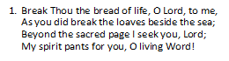
Hymn “Break Thou the Bread of Life. . .”” [# 163 VIP]

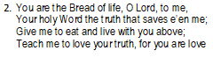
Old Testament: Genesis 29: 15 – 28 – Bro. Donovan Rookwood

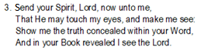
Epistle: Romans 8: 26 – 39 – Sis Tamara McGowan

The Gospel: Matt. 13:31—33; 44—52 — Rev’d Dr. Oral Thomas
Hymn “We Have Heard A Joyful Sound. . .” [# 184 VIP]
Sing it softly thru the gloom
When the heart for mercy craves
Sing in triumph o’er the tomb
Jesus saves! Jesus saves!
- Give the winds a mighty voice
Jesus saves! Jesus saves!
Let the nations now rejoice
Jesus saves! Jesus saves!
Shout salvation full and free
To every shore of ocean’s waves
This our song of victory,
Jesus saves! Jesus saves!
Priscilla J. Owens (1829—1899)

- We have heard the joyful sound
Jesus saves! Jesus saves!
Spread the gladness all around
Jesus saves! Jesus saves!
Bear the news to every land
Climb the steeps and cross the waves
Onward! ‘tis our Lord’s command
Jesus saves! Jesus saves!
- Sing above the battle’s strife
Jesus saves! Jesus saves!
By His death and endless life,
Jesus saves! Jesus saves!

Sermon – Rev’d Dr. Oral Thomas
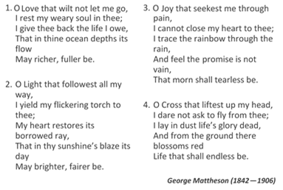
Hymn of Response “O Love That Will Not Let Me Go, , ,” [# 262 VIP]

Announcements
Prayer of Intercession: -- Sis. Christine Carmen Bogle
L: Sovereign Lord, we draw near … to call out to you. Hear our cry, O God…
P: Listen to our prayer
L: Almighty and enabling God . . . Hear our cry, O God,
P: Listen to our prayer
L: Omnipresent God, give courage . . . Hear our cry, O God,
P: Listen to our prayer
L: Everlasting God, may we not neglect … Hear our cry, O God,..
P: Listen to our prayer
L: Compassionate God, heal the sick, . . .risk of infection of COVID-19. Hear our cry, O God.
P: Listen to our prayer
L: Merciful God, comfort and . . . Hear our cry, O God,
P: Listen to our prayer
L: We praise you, Lord . . . in the name of Jesus, Amen.

The Lord’s Prayer

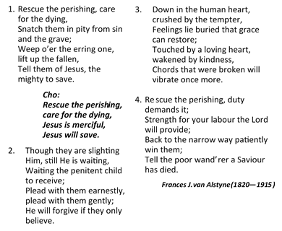
Closing Hymn – “Rescue The Perishing....” [# 180 VIP]

Benedict ion

The Methodist Church in the Caribbean
and the Americas (MCCA)

Jamaica District

METHODIST VOICES IN WORD AND SONG
TELEVISION MINISTRY
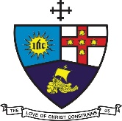

8th Lord’s Day after Pentecost
Sunday, July 26, 2020

DIVINE WORSHIP
Officiating Clergy:
Preacher: Rev. Dr. Oral Thomas,
President, UTCWI
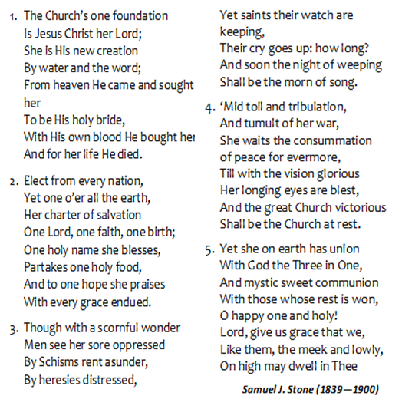
Liturgist: Sis. Dr. Sherlette Rookwood-Brown
Preacher & Congregational Steward
Organist: Bro. Donovan Rookwood
Preacher & Congregational Steward)
Soloist: Sis. Justine Rookwood
Participants: Members of the Gordon Town Congregation
Christine Carmen Bogle
Leethie Davis
Delores McEwan
Patricia McGowan
Wayne Mc Gowan
Tamara McGowan
Deon Reid
Rayan Whitehorne
Andrea Ulett

District Bishop: Rev’d Christine Gooden- Benguche
District Secretary: Rev’d Dr. Wayneford McFarlane
A warm welcome to all worshippers!

