Order of Worship

Introit: “Bless The Lord, O My Soul. . .”
all to Worship
L: People of God, you are welcome in the presence of God, no matter what has happened in your life.
R: We worship the God who sees the end from the beginning and already knows the outcome of every situation.
L: People of God, you are welcome in the presence of God, no matter how you look.
R: We rejoice to know that God looks beyond good looks or accomplishments, wealth or social connections; God sees the heart.
L: No matter who we are or how life has treated us…
ALL: We are all welcome in God's house!
L: We will live as children of light -- for the fruit of the light is found in all that is good and right and true.
R: May Christ come and shine upon us! Come, Lord Jesus, come!
L: Let us worship God

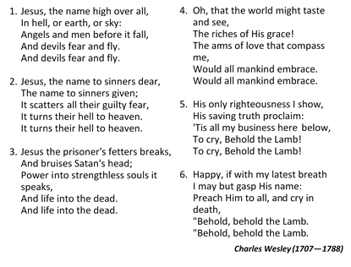
Opening Hymn: “Jesus The Name High Over All” [# 49 VIP]

Prayers of Adoration
L: Let us Pray. Blessed are you Lord and God, in your love you create all things out of Nothing through your eternal word
R: We glorify and adore you
L: Blessed are you Lord our God: in your love you redeemed the world. Through our Lord Jesus Christ
R: We glorify and adore you.
L: Blessed are you, Lord our God: in your love you empower your people. Through the gift of the Holy Spirit
R: We glorify and adore you. AMEN
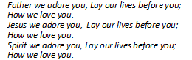
ALL: “Father We Adrore You” (To be sung by all)

Prayers of Confession
L: Let us confess our sins before God. For our foolishness and our thoughtless use of the gifts of your creation
R: Lord have mercy
L: For our neglect of you, and our failure to care for others.
R: Christ have mercy
L: For our selfishness in prayer and our carelessness in worship.
R: Lord have mercy
L: For our sins in thoughts, words and deeds, for our failure to forgive and forget, For our rebellion to your will and purpose for our lives.
R: Christ have mercy
L: Let us sing, “Search Me O God”
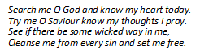

Assurance of Pardon
L: Arise and go in peace and sin no more, your sins are forgiven you
R: Amen, Thanks be to God
L: Let us give Thanks to Almighty God. . . We thank you O God for you are gracious. You have loved us from the beginning of time… And you remember us in times of trouble and of joy.
R: Your mercy endures for evermore
L: We thank you O God for the beauty of the world and for the life that we have been given.
R: Thanks be to you O God.
L: For gifts great and small, for all the blessings of this life, for food, friends, fellowship and family
R: Thanks be you O God.
L: We thank you O God for Jesus Christ, for his suffering and death on the cross and his resurrection to new life. For the salvation he wrought for us, we bless you Lord.
R: Thanks be to you O God
L: We thank you God for every blessing that we have received, for today and the blessings and joy you have in store for us today.
R: We give you thanks and praise
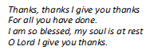
L: Let us sing, “Thanks, Thanks, I Give You Thanks”

Praise in Worship - Sis. Kadian Barnett

MINISTRY OF THE WORD
Collect
Lord, you have taught us that all our doings without love are nothing worth: sent your Holy Spirit and pour into our hearts that most excellent gift of love, the true bond of peace and of all virtues, without which whoever lives is counted dead before you. Grant this for your only Son Jesus Christ's sake.

Old Testament: Psalm 118:14-29 - Sis. Asrey James
Epistle: Revelation 1:1-8 - Sis. Leila Henry
Gospel: John 20:19-31 - Rev’d I. Michael Llewellyn
Sermon - Rev’d Stanley Griffin
Prayer of Commitment

Hymn of Response: “Here I am Lord” [# 455 VIP]
- I, the Lord of sea and sky,
I have heard my people cry,
All who dwell in dark and sin,
My hand will save.
I who made the stars of night,
I will make their darkness bright.
Who will bear my light to them?
Whom shall I send?
Refrain:
Here I am Lord,
Is it I Lord?
I have heard You calling in the night.
I will go Lord, if You lead me.
I will hold Your people in my heart.

“Here I Am Lord. . .” continued
- I, the Lord of snow and rain,
I have borne my people’s pain.
I have wept for love of them,
They turn away.
I will break their hearts of stone,
Give them hearts for love alone.
I will speak my word to them
Whom shall I send?
- I, the Lord of wind and flame,
I will tend the poor and lame.
I will set a feast for the.,
My hand will save.
Finest bread I will provide,
Till their hearts be satisfied.
I will give my life for them,
Whom shall I send?

David L. Shutte (1947— )

Nicene’ Creed [PAGE 72 MPB]
WE BELIEVE IN ONE GOD, the Father Almighty, Creator of heaven and earth, and of all that is, seen and unseen.
We believe in one Lord Jesus Christ, the only Son of God, eternally begotten of the Father, God from God, Light from Light, True God from True God, Begotten, not made, of one Being with the Father. Through Him all things were made. For us human beings, and for our salvation, he came down from heaven. By the power of the Holy Spirit he became incarnate from the virgin Mary and became a human being. For our sake he was crucified under Pontius Pilate; He suffered death and was buried. On the third day He rose again in accordance with the Scriptures. He ascended into heaven and is seated at the right hand of the Father. He will come again in glory to judge the living and the dead and his Kingdom will have no end.
We believe in the Holy Spirit, the Lord, the Giver of Life who proceeds from the Father and who, with the Father and the Son, is worshipped and glorified.
He has spoken through the prophets. We believe in the one holy, catholic
and apostolic Church. We acknowledge one baptism for the forgiveness of sins.
We look for the resurrection of the dead, And the life of the world to come. Amen.

The Lord's prayer
Announcements, Tithes & Offering
The Sacrament of The Lord’s Supper
Communion Hymn: “A Sign of Love …” [# 429 VIP]
- Take the body and the blood of Christ,
In divine revelation of His love,
Be transformed, Oh my people, from your sin
And eat and drink and live!
- He is lifted to the throne on high
And will come again to rule all the world
The saints who sleep in Christ shall rise
Rejoice O Zion and be glad.

- Let us enter into covenant with Christ,
Celebrating the Eucharist of love,
Take a little bread and wine,
Lift up the chalice of the King.
Refrain:
Alleluia, it's a sign of love!
Alleluia, it's a sign of peace.
Alleluia, it's the mystery of faith,
Alleluia, Amen.

- I, the Lord of wind and flame,
Jesus Christ is the Lamb of God,
Who takes away the sin of the World.
He who comes to me,
I shall not turn away.
- Come you faithful to the paradise of God
To the marriage feast of the Lamb.
Eat manna from the tree of life
You are washed in the blood of Christ.

Norbert Farrell (1943— )

Communion Liturgy (PG 76 MPB)

Closing Hymn: “We’ve A Story to Tell to The Nations” [# 460 VIP]
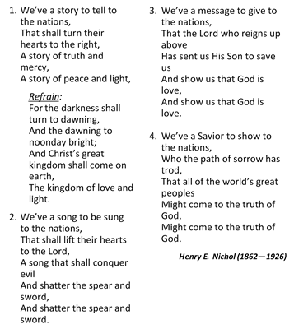

Benediction

The Methodist Church in the Caribbean
and the Americas (MCCA)
Jamaica District

METHODIST VOICES IN WORD AND SONG
TELEVISION MINISTRY
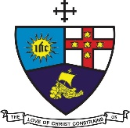

5th Lord’s Day after Pentecost

Sunday, July 5, 2020

SERVICE OF WORD
AND SACRAMENT

Officiating Clergy:
Preacher: Rev’d Stanley Griffin
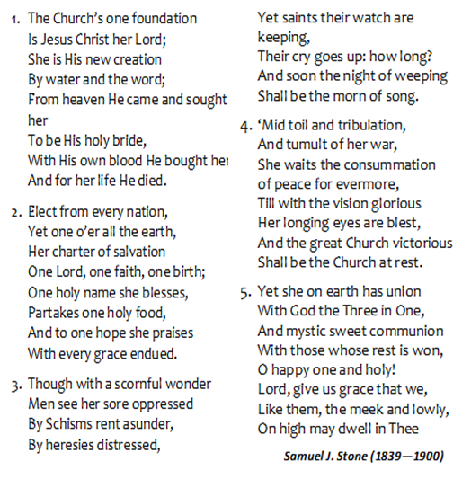
Liturgist: Rev’d I Michael Llewellyn

Organist: Sis. Melrose Davies
Choristers: Sis. Yvonne Brown
Sis. Valerie Hinds
Sis. Marie Miller
Sis. Yvonne Patterson
Bro. Nigel Haye
Praise Leader: Sis. Kadian Barnett

District Bishop: Rev’d Christine Gooden- Benguche
District Secretary: Rev’d Dr. Wayneford McFarlane

A warm welcome to all worshippers!

