Order of Worship
Introit Hymn: “Welcome Holy Spirit”
Call to Worship: - Sis. Joelle Alfred (M.I.T.)
L I will praise Thee O Lord, with my whole heart. I will show faith, all
Thy marvelous works.
.
ALL We will be glad and rejoice in Thee. We will sing praises to Thy
name O Thou Most High.

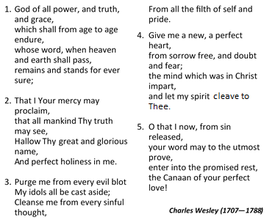
Opening Hymn “God of All Power and Truth and Grace. . .”” [# 293 VIP]

Prayer of Adoration - Sis. Joelle Alfred (M.I.T.)
God Almighty, you are creator and God of all. We praise you for your wondrous works and blessings to us, day after day. The beauty of your creation prompts us to sing Hosanna! Hosanna! to our King, to the one who can do all things. We praise your name for there is none like you in all the universe. Lord we lift your name on high and may your praise ever be on our lips. Amen

Prayer of Confession: - Sis. Joelle Alfred (M.I.T.)
Creator God, we confess to You that we have broken away from Your intention for us. We have abused the earth rather than caring for it. We have been created for goodness by you, but we continue to be filled with bitterness. Your Word would enable us to speak of joy to others, but we offer only judgment. The Spirit which
breathes hope into us could be shared with everyone we meet, but we are tempted to keep it to ourselves, rather than giving peace to those around us. Forgive us and help us to care for one another in a way that reflects our love for You. Amen.

Assurance of Pardon
L: Through Christ Jesus we have received the assurance that when we truly repent of our sins we receive God’s forgiveness and transformational power in our lives.
P: Thanks be to God for his mercy and grace. Amen

Prayer of Thanksgiving - Sis. Joelle Alfred (M.I.T.)
Gracious God, we give you thanks for our many blessings. You wake us up every day, you provide food for us to eat and homes in which we can dwell. You continue to provide blessings God, blessings overflowing like a mighty sea. We thank you for your Son, Jesus Christ, by whom we are saved and in whom we receive life everlasting. We thank you also for the mission of your Church, to go out spreading scriptural holiness in the land. We thank you, O God, and pray that our lives will be offered in thanksgiving out of our love for you, for Christ’ sake. Amen.
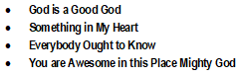
Time of Praise

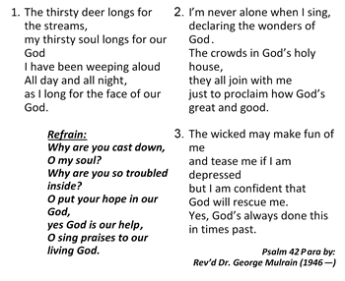
Hymn “The Thirsty Deer Longs for the Streams. . .”” [# 264 VIP]

MINISTRY OF THE WORD
Collect: - Sis. Joelle Alfred (M.I.T.)
Almighty and everlasting God, by whose Spirit the whole body of the Church is governed and sanctified: hear our prayer which we offer for all your faithful people, that in their vocation and ministry they may serve you in holiness and truth to the glory through Jesus Christ our Lord. Amen

Old Testament: Genesis 28:10–19a – Read by Sis. Nesta Brown

Responsive reading: Psalm: 139:1—12; 23—24 (VIP 654)
Led by- Sis. Patricia Beecher
L ¹ O Lord, you have searched me and known me.
R ² You know when I sit down and when I rise up;
you discern my thoughts from far away.
L ³ You search out my path and my lying down,
and are acquainted with all my ways.
R ⁴ Even before a word is on my tongue,
O Lord, you know it completely.
L ⁵ You hem me in, behind and before,
and lay your hand upon me.
R ⁶ Such knowledge is too wonderful for me;
it is so high that I cannot attain it.
L ⁷ Where can I go from your spirit?
Or where can I flee from your presence?
R ⁸ If I ascend to heaven, you are there;
if I make my bed in Sheol, you are there.
L ⁹ If I take the wings of the morning
and settle at the farthest limits of the sea,
R ¹⁰ even there your hand shall lead me,
and your right hand shall hold me fast.
L ¹¹ If I say, “Surely the darkness shall cover me,
and the light around me become night,”
R ¹² even the darkness is not dark to you;
the night is as bright as the day,
for darkness is as light to you.
----------
L ²³ Search me, O God, and know my heart;
test me and know my thoughts.
ALL ²⁴ See if there is any wicked^{[a]} way in me,
and lead me in the way everlasting.
Gloria Patri

Epistle: Romans 8:12—25 – Sis. Barbara Hylton
Gospel: Matt. 13:24-39; 36—43 – Sis. Marcia Cohen
Ministry in Song: “I’m Gonna Live”
Sermon – Rev’d Veron Hussey (Guyana District)
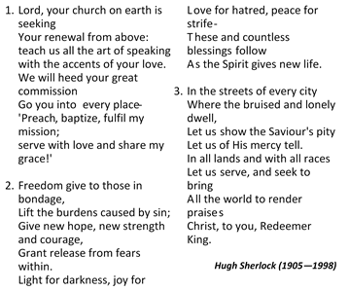
Hymn of Response “Lord Your Church . . . Seeking” [# 456 VIP]

Announcements
Prayer of Intercession: - Sis. Joelle Alfred (M.I.T.)
L: Lord in your mercy,
P: Hear our prayer.
L: Eternal God, it is your will that we pray for those who are in need. We pray, O Lord, for all who are in need, afflicted, persecuted and oppressed, that daily they may experience your relief, comfort, and liberation through Jesus Christ our Lord. Lord in your mercy,
P: Hear our prayer.
L: Eternal God. it is your will that we pray for those who are weak in the faith or confused. We pray, O Lord, for all who are afraid to witness for you because of doubts and fears due to the Covid-19 pandemic. We pray for those who are unstable in their relationships and become unfaithful in their living. Have mercy on those who are uncertain about life and are afraid to face the future. Grant them your Spirit of love and power that they may triumph in your name. Lord in your mercy,
P: Hear our prayer
L: Eternal God, it is your will that we pray for your Church universal. We pray, O Lord, for your church throughout the world, especially the Methodist Church in Jamaica and the MCCA Connexion. May you continually enrich it with the gifts of the Holy Spirit, raising men and women to carry on your mission. Lord in your mercy,
P: Hear our prayer.
L: Eternal God, it is your will that we pray for those who are ill or are experiencing grief. We pray, O Lord, for all who are experiencing sickness of any kind, especially for those affected by the corona virus. They need your healing touch in their lives. We bring before you those that have lost loved ones, especially those who were taken by violence, crime or severe illness. We pray that your comfort and peace will fill their lives. Lord in your mercy,
P: Hear our prayer.
L: We bring these petitions before you and pray that our cries will come unto you, through Jesus Christ our Lord.
All: Amen.

The Lord’s Prayer

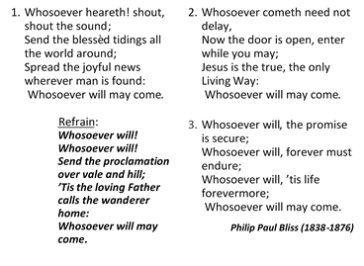
Closing Hymn – “Whosoever Will....” [# 185 VIP]

Benediction

The Methodist Church in the Caribbean
and the Americas (MCCA)

Jamaica District

METHODIST VOICES IN WORD AND SONG
TELEVISION MINISTRY
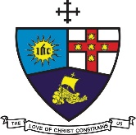

7th Lord’s Day after Pentecost
Sunday, July 19, 2020

DIVINE WORSHIP
Officiating Clergy:
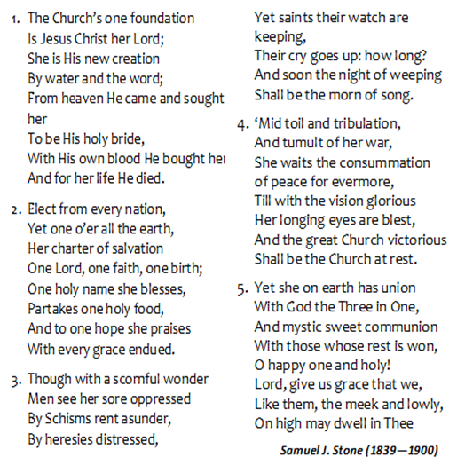
Preacher: Rev’d Veron Hussey (Guyana District)
Liturgist: Sis. Joelle Alfred (Minister-in-Training)

Organist: Bro. Donovan Rookwood
Choristers: Sis. Patricia Beecher
Sis. Nesta Brown
Sis. Marcia Cohen
Sis. Barbara Hylton
Sis. Marjorie McCalla
Sis. Chenee Riley
Sis. Pat Williams
Bro. Nigel Haye
Bro. Keith Nelson
Bro. Paul Thorbourne

District Bishop: Rev’d Christine Gooden- Benguche
District Secretary: Rev’d Dr. Wayneford McFarlane
A warm welcome to all worshippers!

