Order of Worship
Introit Hymn: “Send Me Lord” [# 459B VIP]
Call to Worship: - Rev’d Stephen Mullings

L I will praise Thee O Lord, with my whole heart. I will show faith, all Thy marvelous works.
.
ALL We will be glad and rejoice in Thee. We will sing praises to Thy name O Thou Most High.

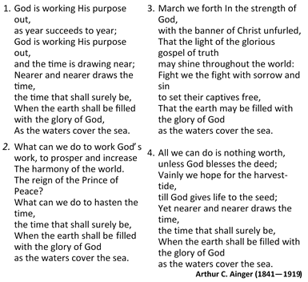
Opening Hymn “God is Working His Purpose Out. . .”” [# 453 VIP]

Prayer of Adoration - Rev’d Claude Samuels
ALL: Chorus: “Bless The Lord, O My Soul” (To be sung by all)
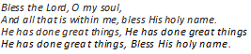

Prayer of Confession: -- Rev’d Claude Samuels
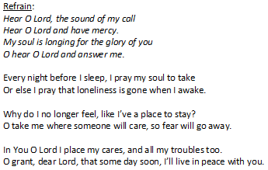
ALL: Chorus: “Hear O. Lord, The Sound of My Call”

Prayer of Thanksgiving -- Rev’d Claude Samuels
ALL: Chorus: “Thank You Lord” (To be sung by all)
And Lord I want to thank you
For your love for me.
I want to thank you Lord
Thank you Lord.
Thank you Lord, thank you Lord
That you ever thought of me.
.

Thank you Lord, thank you Lord
That you ever thought of me.
Thank you Lord, thank you Lord
That you ever thought of me.
Many are the blessings
That you give unto me,
Blessings that surrounds me
Like a mighty sea,
.

Time of Praise:

Special Item - Dance: – Sis. Michelle Goldson

MINISTRY OF THE WORD
Collect: – Rev’d Stephen Mullings
Almighty God, you have broken the tyranny of sin and have sent the Spirit of your Son into our hearts whereby we call you Father: give us grace to dedicate our freedom to your service, that we and all creation may be brought to the glorious liberty of the children of God; through Jesus Christ your Son our Lord. Amen

Old Testament: - Jonah 3:1—5 ; v:10 – Read by Sis. Milicent Smickle

Responsive reading: Psalm: 8:146 (VIP 654)
Led by- Sis. Maleeka Johnson
L ¹ Praise the Lord! Praise the Lord, O my soul!
R ² I will praise the Lord as long as I live;
I will sing praises to my God all my life long.
L ³ Do not put your trust in princes,
in mortals, in whom there is no help.
R ⁴ When their breath departs, they return to the earth;
on that very day their plans perish.
L ⁵ Happy are those whose help is the God of Jacob,
whose hope is in the Lord their God,
R ⁶ who made heaven and earth,
the sea, and all that is in them;
who keeps faith forever;
L ⁷ who executes justice for the oppressed;
who gives food to the hungry.
The Lord sets the prisoners free;
R ⁸ the Lord opens the eyes of the blind.
The Lord lifts up those who are bowed down;
the Lord loves the righteous.
L ⁹ The Lord watches over the strangers;
he upholds the orphan and the widow,
but the way of the wicked he brings to ruin.
ALL ¹⁰ The Lord will reign forever,
your God, O Zion, for all generations.
Praise the Lord!

Epistle: 1Peter 3:8—16 – Sis. Leanora Williams
Gospel - Luke 10: 1—11 – Rev’d Stephen Mullings
Sermon – Bishop the Rev’d Everald Galbraith
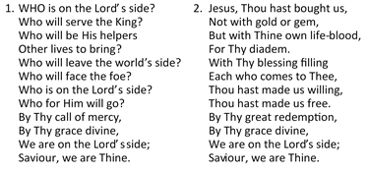
Hymn of Response “Who is on the Lord’s Side? . . .” [# 325 VIP]

“Who is on the Lord’s Side? . . .” [Hymn # 325 VIP] continued
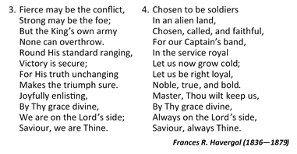

Announcements
Offertory
Prayers of Intercession: - Rev’d Claude Samuels
The Lord’s Prayer
Closing Hymn – “Love Lifted Me.. .” [# 170 VIP]
- I was sinking deep in sin,
far from the peaceful shore, Very deeply stained within,
Sinking to rise no more,
But the Master of the sea,
heard my despairing cry,
From the waters lifted me,
now safe am I.
Refrain:
Love lifted me!
Love lifted me!
When nothing else
could help
Love lifted me!
- All my heart to Him I give,
ever to Him I cling
In His blessed presence live,

Ever His praises sing,
Love so mighty and so true,
merits my soul’s best songs,
Faithful, loving service too,
to Him belongs.
- Souls in danger look above
Jesus completely saves
He will lift you by His love,
Out of the angry waves.
He’s the Master of the sea,
Billows His will obey,
He your Saviour wants to be,
be saved today.
James Rowe (1865—1933)

Benediction

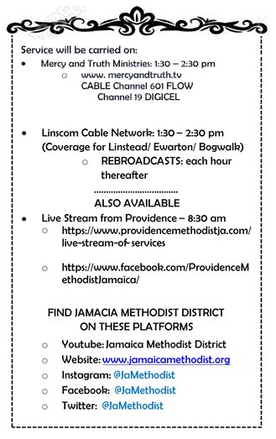

The Methodist Church in the Caribbean
and the Americas (MCCA)
Jamaica District

METHODIST VOICES IN WORD AND SONG
TELEVISION MINISTRY
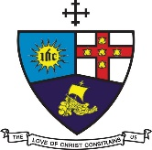

MISSION SUNDAY
Theme: Defending the Faith

Sunday, July 12, 2020

DIVINE WORSHIP
Officiating Clergy:
Preacher: Bishop Everald Galbraith
Liturgists: Rev’d Stephen Mullings
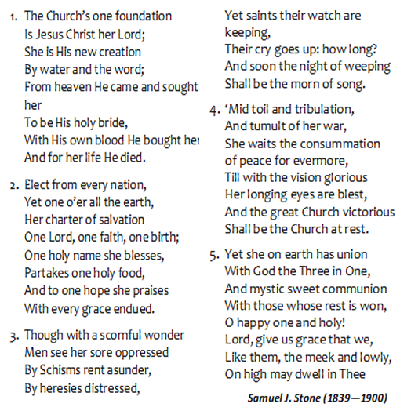
Rev’d Claude Samuels

Organist: Bro. Trevor Brown
Choristers: Sis. Krisan Murphy
Sis. Leanora Williams
Sis. Milicent Smickle
Sis. Natanya Johnson
Sis. Maleeka Johnson

District Bishop: Rev’d Christine Gooden- Benguche
District Secretary: Rev’d Dr. Wayneford McFarlane

A warm welcome to all worshippers on
this glorious Mission Sunday!

