Order of Worship
Introit Hymn: “Jesus We Are Here...” [# 378 VIP]
Call to Worship: – Bro. Jerand Phills, (Minister -In-Training, UTCWI)
WELCOME –
L: Today, Sunday 16th August is the eleventh Lord’s Day after Pentecost. I am Jerand Phills. Whether you are tuned in to this worship service via the Internet, television, cable network or YouTube, you are most welcome. Know that we appreciate your presence. May that this experience together be for us a special blessing!

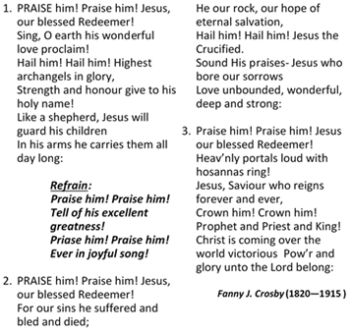
Hymn “Praise Him. . .Jesus Our Blessed Redeemer. . .” [# 55 VIP]

Prayer of Adoration – Bro. Jerand Phills (M.I.T.)
L: Let us pray. We are privileged, dear God, to be alive today and to worship You, O Holy Trinity. As Creator, You brought this world into being with everything in it. To enlighten us about Your divine nature, Your Son Jesus Christ came down to earth in human form. Through His ministry, He declared Your love through who He was, in what He said and in what He did. We acknowledge that His suffering on the cross was because of our sins. Therefore we could sing and acclaim Him as our blessed Redeemer, our rock and our hope of eternal salvation. You also declared Your amazing love through the Holy Spirit who, upon Christ’s return to heaven to be united with You, came to dwell among us. Even now we experience Your divine presence among us. You are worthy of our adoration and worship. Amen.
Prayer of Pardon and Confession: – Bro. Jerand Phills (M.I.T.)
L: We seek Your pardon, though, because we have not readily acknowledged how much we are indebted to You. We go about our daily duties, acting as though we are self-made individuals, completely autonomous and not in need of Your help and strength. It is only when we find ourselves in difficulty that we cry out to You for assistance. Forgive us for being the sinners that we are. Amen.

Prayer of Thanksgiving – Bro. Jerand Phills (M.I.T.)
L: Merciful God, we are thankful for who and what You are, that in spite of our guilt and our folly, You are ever willing to overlook and treat us as cleansed and wise sons and daughters. In accepting now Your forgiveness, may we never take You for granted, but through the grace which we receive from You, strive to improve. May we do this every day, through who we are, in the way we relate to You and to persons we encounter in our local communities and elsewhere. Sanctify this time of worship offered to You, O Holy Trinity, Father, Son and Spirit. Amen!

Praise Time: – FullJoy (Members of the Saxthorpe Praise Team)
Children’s Time – Sis. Tene Joseph, (Minister -In-Training, UTCWI)
Hymn “Bless the Lord, O My Soul. . .” [# 1 VIP]
Bless the Lord, O my soul, And all that is within me,
Bless his holy name.

Andraé Crouch (1945—2015)

Bless the Lord, O my soul, And all that is within me,
Bless his holy name.

He has done great things,
He has done great things,
He has done great things,
Bless his holy name.

MINISTRY OF THE WORD
Collect: – Bro. Jerand Phills (M.I.T.)
L: Almighty God, who called your Church to bear witness that you were in Christ reconciling the world to yourself: help us to proclaim the good news of your love, that all who hear it may be drawn to you; through him who was lifted up on the cross, and reigns with you in the unity of the Holy Spirit, one God, now and for ever. Amen.

Old Testament: Genesis 45:1—15 – Sis. Marie Miller
L: This is the Word of the Lord.
R: Thanks be to God

Responsive reading: Psalm: 133 (VIP 649)
Led by- Sis. Valerie Hinds
L ¹ How very good and pleasant it is
when kindred live together in unity!
R ² It is like the precious oil on the head,
running down upon the beard,
on the beard of Aaron,
running down over the collar of his robes.
L ³ It is like the dew of Hermon,
which falls on the mountains of Zion.
For there the Lord ordained his blessing,
life forevermore.
Gloria Patri
ALL: Glory be to the Father and to the Son and to the Holy Spirit. As it was in the beginning is now and ever shall be, world without end. Amen.

Epistle: Romans 11:1—2a; 29—32 – Sis. Tene Joseph (M.I.T.)
L: This is the Word of the Lord.
R: Thanks be to God

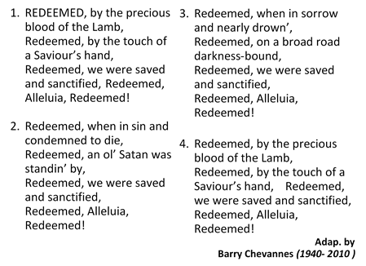
Hymn “Redeemed By the . . . Lamb. . .” [# 92 VIP]

Gospel: Matt. 15:21—28 – Bro. Jerand Phills (M.I.T.)

R: Glory to you, O God.
(After the Gospel has been read . . .)
L: This is the Gospel of Christ.
R: Praise be to Christ, our Lord.

Selection: “People Need the Lord” – Saxthorpe Choristers

SERMON: “Freed to Love and Serve” – Rev’d Dr. George Mulrain,
(Superintendent Minister,
Providence Circuit)

Prayer of Intercession: – Bro. Jerand Phills (M.I.T.)
L: Creator God, bless those who direct the affairs of our nation, including our Governor-General, Prime Minister, Leader of the Opposition, Members of Parliament, the Judiciary and the Security Forces. May the people they serve be willing to cooperate with them, resulting in a safe and disciplined environment, a lessening of crime and violence in homes and on the streets! Curtail the presence of guns, knives and other weapons in day to day human interaction. For persons who have committed evil acts, may they acknowledge their wrongdoing and pledge to turn away from their wickedness! May there come the time when boys, girls, men and women will love and serve You, and walk in Your ways. Lord in your mercy..
R: Hear our prayer.
L: O Triune God – Father, Son and Spirit – continue to be in control of the world’s affairs. Direct the heads of our churches as they exercise the authority You permit them to have. May they ever surrender to Your authority and serve with dignity, honesty, humility and love. And may each one of us consecrate ourselves to love, serve and to do Your will now and always! Lord in Your mercy,
R: Hear our prayer!
L: Finally, we remember in Your presence those who have died. Grant that we may follow the example of those saints who have walked in faith during their time on earth. May we, like them, be prepared to be with You at the last, we humbly pray! AMEN.

The Lord’s Prayer

Announcements

Hymn “We are Marching in the Light of God. . .” [# 340b VIP]
(English)
- We are marching in the light of God,
We are marching in the light of God,
We are marching in the light of God,
We are marching in the light of God,
We are marching, We are marching,
We are marching, Oh!
We are marching in the light of God,
We are marching, We are marching,
We are marching, Oh!
We are marching in the light of God,

- We are living in the love of God,
We are living in the love of God,
We are living in the love of God,
We are living in the love of God,
We are living, We are living,
We are living, Oh!
We are living in the love of God!
We are living, We are living,
We are living, Oh!
We are living in the love of God!

- We are moving in the power of God.
We are moving in the power of God.
We are moving in the power of God.
We are moving in the power of God.
We are moving, We are moving,
We are moving, Oh!
We are moving in the power of God!
We are moving, We are moving,
We are moving, Oh!
We are moving in the power of God!

African origin, edited by Anders Nyberg (1955- )
vv. 2, 3 by Andrew Maries

Benediction – Rev’d Dr. George Mulrain
(Superintendent Minister, Providence Circuit)

The Methodist Church in the Caribbean
and the Americas (MCCA)
Jamaica District

District Theme:
Spreading scriptural holiness to reform the nation…
beginning with me

METHODIST VOICES IN WORD AND SONG
TELEVISION MINISTRY
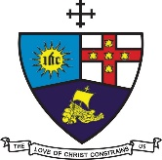

11th Lord’s Day After Pentecost

Sunday, August 16, 2020

DIVINE WORSHIP

Participating Clergy:
Preacher: Rev’d Dr. George Mulrain,
(Superintendent Minister, Providence Circuit)
Liturgist: MIT Jerand Phills

Organist: Sis. Melrose Davies
Choristers: Sis. Yvonne Brown
Sis. Lucette Cargill
Sis. Valerie Hinds
Sis. Marie Miller
Sis. Yvonne Patterson
Bro. Nigel Haye
Praise Team: Sis. Winsome Exell
Sis. Judy-Marie Campbell
Sis. Michelle Goldson
Children’s Time: MIT Tene Joseph

District Bishop: Rev’d Christine Gooden- Benguche
District Secretary: Rev’d Dr. Wayneford McFarlane

A warm welcome to all worshippers!

