Order of Worship
Introit Hymn: “Land of My Birth. . .” [# 523 VIP; V:1 & 4]
Call to Worship: - Rev’d Dr. Wayneford McFarlane
L: Let us celebrate the God who gives life.
P Glory to God who created us human beings in the divine image and likeness.
L: Let us celebrate the equality that Christ proclaims for all people.
P: Jew and Greek, male and female, slave and free are all one.
L: Let us celebrate the signs of renewal in earth and in heaven.
P: We avail ourselves for the Holy Spirit to fashion us as new persons in Christ.

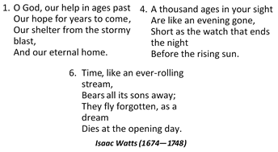
Opening Hymn “O God Our Help in Ages Past. . .” [# 527 VIP- v: 1, 4 & 6]

Prayer of Adoration - Rev’d Dr. Wayneford McFarlane
L: Two hundred years after the Abolition of slavery . . . freedom and equality.
P: Through the power of the Holy Spirit inspire Your people so that they may ever walk in the light of Your truth.
ALL In the name of Christ! Amen.

Prayer of Confession: - Rev’d Dr. Wayneford McFarlane
L: We confess, O God, that many forefathers and mothers . . . indifferent to the inhumane treatment suffered by other human beings.
P: We confess our unwillingness to forgive, our desire to perpetuate hatred and our blatant refusal to embrace a path that will lead to the healing of division.
L: Let each of us in silence confess our sins and pray for God’s forgiveness.
(Silent Confession)

Assurance of Pardon - Rev’d Dr. Wayneford McFarlane
We gratefully receive the forgiveness of God. We pledge to encourage others to repent of their sins, to strive to do justly, and to forgive that they too may be forgiven. Amen.

Time of Thanksgiving – ‘FullJoy’ (Members of the Saxthorpe Praise Team)
- Give Thanks with A Grateful Heart
- Thanks, Thanks I Give You Thanks
- When Trouble in Your Life, Sing Praises
- Jehovah is Your Name

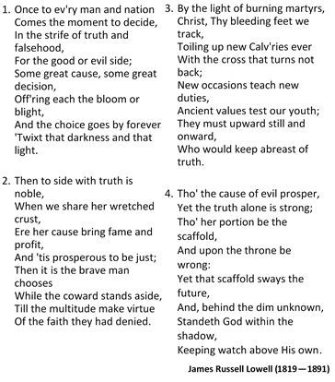
Hymn “Once to Ev’ry Man and Nation. . .” [# 898 MHB]

MINISTRY OF THE WORD
Collect: - Rev’d Dr. Wayneford McFarlane
Creator God, you made us all in your image: may we discern you in all that we see and serve you in all that we do; through Jesus Christ our Lord. Amen

Old Testament: Ezra 3:10–13 – Sis. Joelle Alfred (Minister-in-Training)
Responsive reading: Psalm: 17:1—7; 15 (VIP 576)
Led by- Sis. Marie Miller
L ¹ Hear a just cause, O Lord; attend to my cry;
give ear to my prayer from lips free of deceit.
R ² From you let my vindication come;
let your eyes see the right.
L ³ If you try my heart, if you visit me by night,
if you test me, you will find no wickedness in me;
my mouth does not transgress.
R ⁴ As for what others do, by the word of your lips
I have avoided the ways of the violent.
L ⁵ My steps have held fast to your paths;
my feet have not slipped.
R ⁶ I call upon you, for you will answer me, O God;
incline your ear to me, hear my words.
L ⁷ Wondrously show your steadfast love,
O savior of those who seek refuge
from their adversaries at your right hand.
ALL ¹⁵ As for me, I shall behold your face in righteousness;
when I awake I shall be satisfied, beholding your likeness. Gloria Patri

Epistle: Romans 9:1—5 – Sis. Yvonne Patterson
Gospel: Matt. 14:13-21 – Rev’d Dr. Wayneford McFarlane
Solo: “Lift Every Voice and Sing” – Sis. Lucette Cargill
Sermon – Bishop Rev’d Moses Benguche
Hymn of Response “Send Me Lord . . .” [# 459b VIP]
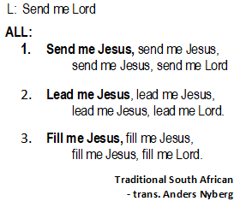

Nicene’ Creed [PAGE 72 MPB]
WE BELIEVE IN ONE GOD, the Father Almighty, Creator of heaven and earth, and of all that is, seen and unseen.
We believe in one Lord Jesus Christ, the only Son of God, eternally begotten of the Father, God from God, Light from Light, True God from True God, Begotten, not made, of one Being with the Father. Through Him all things were made. For us human beings, and for our salvation, he came down from heaven. By the power of the Holy Spirit he became incarnate from the virgin Mary and became a human being. For our sake he was crucified under Pontius Pilate; He suffered death and was buried. On the third day He rose again in accordance with the Scriptures. He ascended into heaven and is seated at the right hand of the Father. He will come again in glory to judge the living and the dead and his Kingdom will have no end.
We believe in the Holy Spirit, the Lord, the Giver of Life who proceeds from the Father and who, with the Father and the Son, is worshipped and glorified.
He has spoken through the prophets. We believe in the one holy, catholic and apostolic Church. We acknowledge one baptism for the forgiveness of sins. We look for the resurrection of the dead, And the life of the world to come. Amen.

Announcements

Sacrament of Holy Communion - Rev’d Dr. Wayneford McFarlane

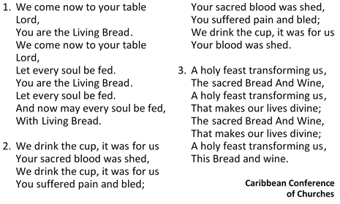
Communion Hymn “We Come Now to Your Table Lord. . .” [# 441 VIP]

Communion Liturgy [PG. 95 MPB)

Prayer of Intercession: - Rev’d Dr. Wayneford McFarlane
L: Let us, as we celebrate the Act to Abolish the Slave Trade, pray for the onward march of individuals, movements and organizations involved in affirming the dignity of all persons made in the divine image and likeness.

P: Gracious God, hear our prayer.
L: Let us ask God to prick the consciences of those who lure children and young people into pornography and prostitution, so that throughout the nations within the Caribbean and the Americas there might be developed greater respect for human life and freedom.
P: Gracious God, hear our prayer.
L: Let us ask God to touch the hearts of those who are involved in human trafficking, who carry out kidnappings of innocent folk, that we might see the release of all who have been held against their will, enslaved or unjustly imprisoned.
P: Gracious God, hear our prayer.
L: Let us pray for the day when any trade that dehumanizes or mars human lives, including the trade in drugs and in ammunition, might cease, and this for the sake of peaceful and harmonious existence.
P: Gracious God, hear our prayer.

The Lord’s Prayer

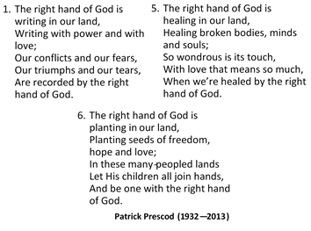
Closing Hymn – “The Right Hand of God....” [# 525 VIP]
(verses 1, 5 & 6)

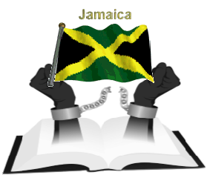
Benediction

The Methodist Church in the Caribbean
and the Americas (MCCA)

Jamaica District

METHODIST VOICES IN WORD AND SONG
TELEVISION MINISTRY
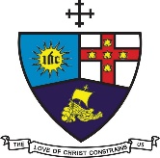

EMANCIPATION SUNDAY
Sunday, August 2, 2020

SERVICE OF WORD
AND SACRAMENT
Officiating Clergy:
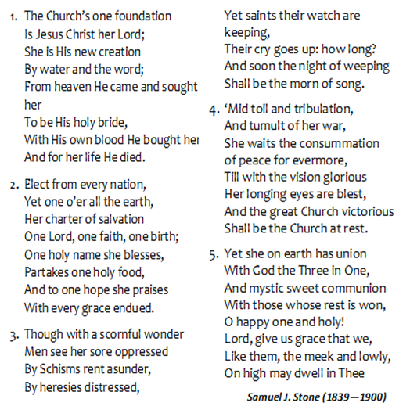
Preacher: Bishop Moses Benguche
Liturgist: Rev’d Dr. Wayneford McFarlane

Organist: Sis. Melrose Davies
Choristers: Sis. Yvonne Brown
Sis. Valerie Hinds
Sis. Marie Miller
Sis. Yvonne Patterson
Bro. Nigel Haye
Soloist: Sis. Lucette Cargill

Praise Team: Sis. Winsome Exell
Sis. Judy-Marie Campbell
Sis. Michelle Goldson

District Bishop: Rev’d Christine Gooden- Benguche
District Secretary: Rev’d Dr. Wayneford McFarlane
A warm welcome to all worshippers, on this
glorious Emancipation Sunday!

