Order of Worship
Introit Hymn: “Holy Spirit Rain Down”
Call to Worship: - Rev’d Christine Gooden-Benguche
L: Come to Christ, the living stone, rejected by the world, but in God's sight chosen and precious.
R We have responded to Christ's call, and seek to be built into a spiritual house.
L: Once we were no people, but now we are God's people.
R: Called out of darkness into God's marvelous light.
ALL: Blessed be the name of the Lord our God, by your mercy we have been born anew to a living hope.

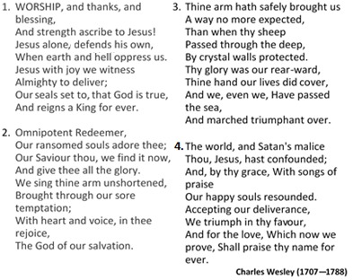
Hymn “Worship and Thanks and Blessing. . .” [# 247 VIP]

Prayer of Adoration - Rev’d Christine Gooden-Benguche
L: With all our hearts we take refuge in God most high, who created all things, the merciful Father, Source of all goodness. With all our heart we take refuge in Christ who has guided and shaped us as a nation and a people. God who has led us thus far along the way we worship and adore you. With all our hearts we take refuge in a God who has been our help in ages past and a present help with in our lives each day. Mercifully hear us we beseech you. Amen

Prayer of Confession: - Rev’d Christine Gooden-Benguche
L: Gracious Lord there are times when our patriotism is blind, times we are consumed by pride that prevents us from seeing each other as brothers and sisters.
R Forgive and pardon us good Lord
L: Forgive us when we continue to take the lives of the innocent and forget the vulnerable and weak among us
R Forgive and pardon us good Lord
L: Forgive us for our slowness to forgive and our destruction of the foundation laid by our fore parents. Forgive our anger, malice, injustice, our willful ignorance of your ways, our infliction of cruelty upon others through word and action.
R Forgive us good Lord.
L: When we thrive at the expense of others and forget that we are nation builders and our brothers and sisters’ keeper.
ALL: Pardon and forgive us dear Lord.

Assurance of Pardon - Rev’d Christine Gooden-Benguche
L: The Lord is gracious slow to anger and abounding in love. May Almighty God grant us remission of all our sins as we come in true repentance asking that he transforms our hearts and minds. We receive the embrace of his love and cleansing power in the name of the risen Christ. Amen.

Prayer of Thanksgiving - Rev’d Christine Gooden-Benguche
L: Lord we give you thanks for the land of our birth:
For its language and all who have taught us to love it so very well, For history and culture, for architecture, technology, education and learning
R: We give thee thanks Oh Lord
L: For the beauty of the mountains, the lush plains and fertile ground For rivers, streams, fields and valleys
R: We give thee thanks Oh Lord
L: For the people of this land and our journey over fifty-eight years and your guiding hand.
R: We give thee thanks Oh Lord

time of Praise – Bro. Courtney Moseley and Team
(Sis. Jacquline Mason and Sis. Patricia Beecher)
- Caribbean Medley
- If it had not been for the Lord
- Your grace and mercy

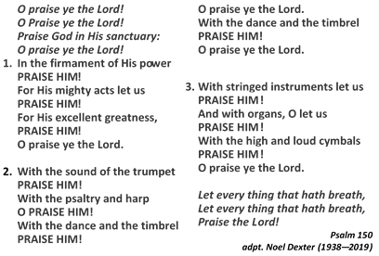
Hymn “O Praise Ye the Lord . . .” [# 24 VIP]

MINISTRY OF THE WORD
Collect: - Rev’d Christine Gooden-Benguche
L: Generous God, you give us gifts and make them grow: though our faith is small as mustard seed, make it grow to your glory and the flourishing of your kingdom; through Jesus Christ our Lord. Amen

Old Testament: 1 Kings 19:9—18 – Bro. Matthew Wright

Responsive reading: Psalm: 133 (VIP 616)
Led by- Sis. Chenee Riley
L ¹ How very good and pleasant it is
when kindred live together in unity!
R ² It is like the precious oil on the head,
running down upon the beard,
on the beard of Aaron,
running down over the collar of his robes.
L ³ It is like the dew of Hermon,
which falls on the mountains of Zion.
For there the Lord ordained his blessing,
life forevermore.
Gloria Patri

Epistle: Romans 10:5—15 – Bro. Courtney Moseley
Gospel: Matt. 14:22—33 – Bro. Glaister Ricketts

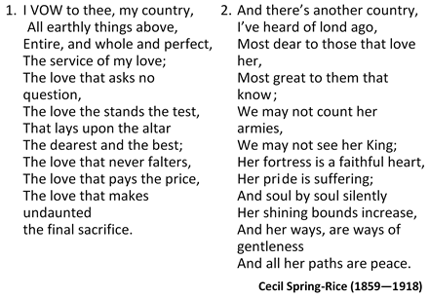
Hymn “I Vow to Thee My Country....” [# 524 VIP]

Sermon – Rev’d Paul Douglas Walfall
(United Church of Canada)

Announcements

Prayer of Intercession: - Rev’d Christine Gooden-Benguche
L: Lord, in your mercy:
R: Hear our Prayer

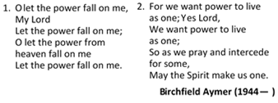
HYMN “O Let the Power Fall on Me...” [# 155 VIP] (vs 1, 2)

The Lord’s Prayer

Commission & Benediction - Rev’d Christine Gooden-Benguche
Go now and make known the power and coming
of our Lord Jesus Christ.
Bow at God’s feet,
and serve the Lord with joy.

national Anthem
Eternal Father, Bless our Land,
Guard us with thy mighty hand,
Keep us free from evil powers,
Be our light through countless hours,
To our leaders, great defender,
Grant true wisdom from above,
Justice, truth be ours forever,
Jamaica, land we love,
Jamaica, Jamaica,
Jamaica, land we love.

Teach us true respect for all,
Stir response to duty’s call,
Strengthen us the weak to cherish,
Give us vision lest we perish,
Knowledge send us Heavenly Father,
Grant true wisdom from above,
Justice, truth be ours forever,
Jamaica, land we love,
Jamaica, Jamaica,
Jamaica, land we love.
Hugh Sherlock (1905-1998)

The Methodist Church in the Caribbean
and the Americas (MCCA)

Jamaica District

METHODIST VOICES IN WORD AND SONG
TELEVISION MINISTRY

INDEPENDENCE LORD’S DAY
Sunday, August 9, 2020

DIVINE WORSHIP
Officiating Clergy:
Preacher: Rev’d Paul Douglas Walfall
Liturgist: Bishop Christine Gooden-Benguche

Organist: Bro. Donovan Rookwood
Violinists: Sis. Helen Bromley
Bro. Matthew Wright
Choristers:
Sis. Patricia Beecher Sis. Jacqueline Morgan
Sis. Nesta Brown Sis. Colleen Nembhard
Sis. Marcia Cohen Bro. Nigel Haye
Sis. Barbara Hylton Bro. Paul Thorbourne
Sis. Marjorie McCalla

Praise Team: Bro. Courtney Moseley
Sis. Jacquline Mason
Sis. Patricia Beecher

District Bishop: Rev’d Christine Gooden- Benguche
District Secretary: Rev’d Dr. Wayneford McFarlane
A warm welcome to all worshippers, on this
glorious Independence Sunday!

