Order of worship
Call to worship
L: Let everyone who serves God come and offer praises unto His holy name.
P: We praise You O God for your love never fails
L: Let all who are gathered in this place lift our hands and raise our voices in praise to our God. Young men and maidens, fathers and mothers, godparents, children all, let us shout praises to God for we are his people.
P: Hallelujah! Praise the name of our God of all blessing and honour, power and might, glory and redemption.
L: Let the children come and do not prevent them
P: For the kingdom of heaven belongs to such as these.
Hymn – 493 VIP All things bright
Responsive Reading –Psalm 8
Prayers of Adoration, Confession, and Thanksgiving
Praise Time
Hymn 478 VIP Praise Him, Praise Him, all ye little children:
God is love! God is love
Love Him, Love Him……Thank Him Thank Him…..Serve Him, Serve Him….

Readings by Children and Youth
Baby Moses: And the Levite woman conceived and bore a son; and when she saw that he was a fine baby, she hid him for three months.
Baby Isaac: And Sarah bore a son. Abraham called the name of his son Isaac. And Sarah said, ‘God has made me laugh and everyone who hears will laugh with me.”
Baby Samuel: And Hannah bore a son and she called his name Samuel, saying, “Because I asked the Lord for him, my heart rejoices in the Lord.”
Baby John the Baptist: Now Elizabeth brought forth a son; and her neighbors and kinsfolk rejoiced with her.
Baby Jesus: And Mary brought forth her first born son and laid him in a manger… And the angels said to the shepherds, ‘I bring you good tidings of great joy, for there is born to you this day in the city of David, a Saviour who is Christ the Lord.
Hymn – Father lead me day by day VIP 467
DECLARATION OF PURPOSE (read by children and youth)
Reader 1: We are gathered here today to celebrate the youngest members of our church family. By the sign and seal of the Sacrament of the Holy Baptism and the power of the Holy Spirit, we welcome these children into the Methodist Church. Today is therefore a day of rejoicing as we recall those promises which were made at that high moment.
Reader 2: This morning we remind the congregation of the promises made at Baptism. We promised to maintain a quality of worship in order that children may grow in grace and to know Jesus Christ as Lord, Saviour and friend. Are we being true to our promise? (Brief moment of silence)
Reader 3: Parents and godparents, you also made promises. Parents, you have promised to provide a Christian home for these children, filled with love and faithfulness. You promised to set the right examples for your children and to encourage them to become confirmed members of this church. Godparents, you have pledged to support these parents in the nurturing, disciplining, and positive influencing the lives of these children. Are we being faithful to your promises?
(Brief moment of silent reflection)
All: Today is a day for remembering and also a day for anticipating great possibilities. May God help us to reflect seriously upon our promises, that we may be confident of the never failing presence of Jesus Christ, our Saviour, Lord and friend. Amen

Old Testament – Deuteronomy 6:1-9
Epistle: Ephesians 6:1-9
Introduction and comments by Cradle Roll Secretary
Invitation to children being enrolled and parents to stand at the communion rail
Prayer by preacher
Child’s Month Message -
Presentation of certificates and tokens
Hymn: 479 VIP – Jesus love me this I know
Gospel – Luke 18:15-17
Chorus …. Alle Alle … Alle-lu-ia…
Sermon
Hymn 483VIP This little light of mine, I’m gonna let it shine X 3
Everywhere I go, I’m gonna let it shine X3
All through the night, I’m gonna let it shine
Notices & Offering
Prayers of Intercession & Lord’s Prayer
Hymn 339 VIP Stand up stand up
Benediction

The Methodist church in the Caribbean and the Americas
Jamaica Methodist District
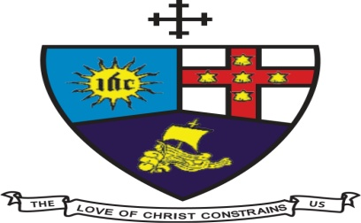

CRADLE ROLL LORD’S DAY- MAY 16, 2021
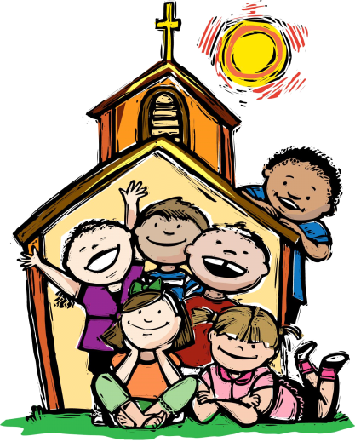

Liturgist:
Preacher:
Musician

