Children’s Work Commission Message – Children’s Lord’s Day/Cradle Roll Sunday
May 16th 2021 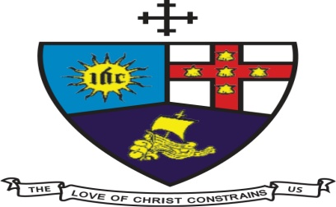

Happy Child’s Month and Happy first Children’s Day within the Jamaica District! We trust that you are coping well and keeping safe as you continue to live during the pandemic.
The year 2021 is the year that the Children’s Work Commission embark on the journey to have its first Children’s Sunday on Sunday May 16, 2021.
This present context in which we live in 2021 has had some drastic changes to the way we now have to operate. In spite of the current crisis, it gives me great pleasure in addressing our children across the District on this Children’s Sunday. We are aware of the present situation which affects you in various ways, especially having to be home schooled and stay in place; having to miss your friends and outdoor activities. Please be encouraged in the various circumstances that you are facing.
I wish you a happy child’s month/children’s Sunday on behalf of the Children’s Work Commission. We also want to express our need of you to be safe and remain hopeful. Bearing in mind that even in the midst of this pandemic, children are still being abused, mistreated and murdered. We as a District will endeavor to keep you prayed up and continue to keep in touch through the various social media platforms.
As a church, we believe that you are special, God’s wonderful gift to the world. Psalms 139:14 reminds us that; You are fearfully and wonderfully made.
I invite all our leaders, and especially children’s workers to continue to reach out to our children and offer spiritual, psychological and emotional guidance and nurture them in these challenging times.
As a reminder, the Safeguarding policy in its ‘Statement of Commitment is urging us to:
- Prevent any form of maltreatment
- Promote the wellbeing of our children and the vulnerable
- Addressing suspected cases of maltreatment in a timely manner.
As the district sub-theme for this year states, we need to care for the souls of our children, it is our duty as a church to be there for our children. Please have the District monthly prayer charts made available to our children.
The children’s work commission has also re launched the Methodist children’s Fellowship handbook and we will hosts our first virtual Methodist Children’s Fellowship on Saturday May 22, 2021 at 4:30pm on zoom platform. The link will be sent subsequently.

Young ones continue to remain safe and hopeful as you deal with this present reality which is affecting us all. May God’s protection and blessings remain with you, now and always.

Rev. Racquel Clemming Sis. Ruth Ann Benguche
Secretary of Children’s Work Comminssion Assistant Secretary

